**Step 5.**

**The if Statement**

Well done! You’re making great progress. On to module 3!  
  
Often when we write code, we want to perform different actions based on different conditions.  
  
And this is where **conditional statements** come in.  
  
There are a bunch of different conditionals, to cover, but we’re starting with one of the most useful: "if"  
  
We use **if**to specify a block of code that we want to be executed if a specified condition is true.

if (condition) {   
statements   
}

The statements will only be executed if the specified condition is **true**. Let’s take a look at an example:

var myNum1 = 7;   
var myNum2 = 10;   
**if** (myNum1 < myNum2) {   
alert("JavaScript is easy to learn.");   
}

**Result:**

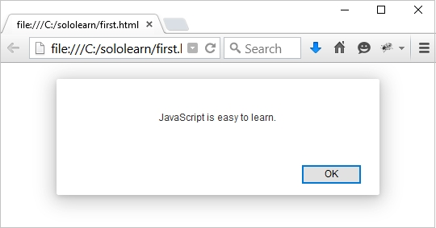

**Heads up!**  
You can see from the example above, we’ve used the JavaScript **alert()** to generate a popup alert box that contains the information inside the parentheses.

**The if Statement**  
  
Here’s a little more detail on the if statement.  
  
This is an example of a **false**conditional statement:

var myNum1 = 7;   
var myNum2 = 10;   
if (myNum1 **>** myNum2) {   
alert("JavaScript is easy to learn.");

Because the condition evaluates to false, the alert statement gets skipped and the program continues with the line after the if statement's closing curly brace.

**Heads up!**  
**if** is in lowercase letters. Uppercase letters (If or IF) won’t work.

**The else Statement**

Right, so we’ve seen that the action gets skipped when a code block using the if statement evaluates to false, but what if we want something else to happen.  
Well, we use the "else" statement, of course!  
  
We can use the **else**statement to specify a block of code that will execute if the condition is **false**. Like this:

if (expression) {   
// executed if condition is true   
}   
**else** {   
// executed if condition is false   
}

**Heads up!**  
You can skip the curly braces if the code under the condition contains only one command.

**The else Statement**

Here’s another example of the **if**and **else**statements working together:

var myNum1 = 7;   
var myNum2 = 10;   
if (myNum1 > myNum2) {   
alert("This is my first condition");   
}   
else {   
alert("This is my second condition");   
}

Let's translate that example. It says:  
- **If**myNum1 is greater than myNum2, alert "This is my first condition";  
- **Else**, alert "This is my second condition".  
  
So the browser will print out the second condition, as 7 is not greater than 10.

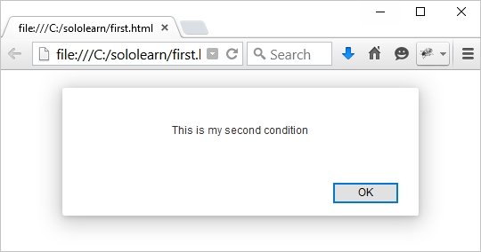

**Heads up!**  
There's another way to do this check using the ? operator: a > b ? alert(a) : alert(b).

**else if**

We've seen **else**, we've seen **if**, time to meet **else if**.  
  
The **else if** statement is useful because it lets us specify a new condition if the first condition is false.  
  
**Like this:**

var course = 1;   
**if** (course == 1) {   
document.write("<h1>HTML Tutorial</h1>");   
} **else if** (course == 2) {   
document.write("<h1>CSS Tutorial</h1>");   
} **else** {   
document.write("<h1>JavaScript Tutorial</h1>");   
}

This is what's happening in the code above:  
- **if**course is equal to 1, output "HTML Tutorial";  
- **else**, **if**course is equal to 2, output "CSS Tutorial";  
- if none of the above condition is true, then output "JavaScript Tutorial";  
  
**course**is equal to 1, so we get the following result:

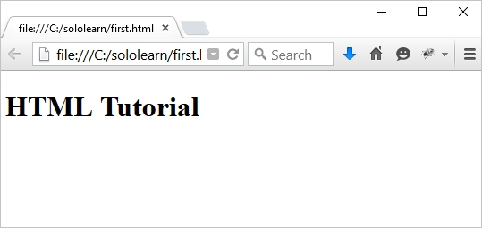

**Heads Up!**  
The final **else**statement "ends" the **else if** statement and should be always written after the **if**and **else if** statements.

**else if**

The final **else**block will be executed when **none**of the conditions is true.  
  
Let's change the value of the **course**variable in our previous example.

var course = 3;   
if (course == 1) {   
document.write("<h1>HTML Tutorial</h1>");   
} else if (course == 2) {   
document.write("<h1>CSS Tutorial</h1>");   
} else {   
document.write("<h1>JavaScript Tutorial</h1>");   
}

**The result:**

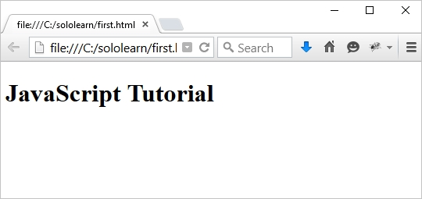

You can write as many **else if** statements as you need.